

Template – Customization, Requirement, Improvement, Modification (CRIM) Specification

Tunstall Healthcare (UK) Limited

|  |  |  |
| --- | --- | --- |
| **Object No.** | **Priority** | **Description** |
| C0280 | 1 | Custom Migration Job |
|  |  |  |
|  |  |  |
|  |  |  |

This document has been approved by

|  |  |
| --- | --- |
|  | Matt Commins |
| Tunstall Solutions Architect | Workstream Lead/BA - Warehousing |
|  | 04/02/2021 |
| Date | Date |

Document Revision History

|  |  |  |  |
| --- | --- | --- | --- |
| Revision | Date | Author | Remarks |
|  |  |  |  |
|  |  |  |  |
|  |  |  |  |
|  |  |  |  |
|  |  |  |  |
|  |  |  |  |

Table of Contents

1 Purpose and Guideance 4

2 Open Issues/Decisions Required 5

3 Specification Requirements and References 6

3.1 Specification Requirements 6

3.2 Reference Points for the Specification 6

3.3 Sources and Dependencies 6

4 Solution Description 7

4.1 Description 7

4.2 Sub Function <Replace with Sub Function title> 7

4.2.1 Functional Requirement and Prerequisites 7

4.2.2 Functional Solution 7

4.3 Sub Function <Replace with Sub Function title> 7

4.3.1 Functional Requirement and Prerequisites 7

4.3.2 Functional Solution 7

5 Limitations 7

6 Glossary/Acronyms 8

7 Change log 9

7.1 Change log for revision XX 9

# Purpose and Guideance

This document captures the **CRIM Specification** requirements relevant for the Customization, Requirement, Improvement or Modification of the standard **IFS** application solution. This document also defines what dependent functions (if applicable) must be changed or developed to solve the solution design and to meet the business requirements.

**Section 2.** **Open Issues/Decisions Required** should detail if there are any known open or outstanding issues together with the person responsible for any resolution activity. Any open issues that required a decision would need to be resolved or completed prior to work starting on the development of the required **CRIM** itself.

**Section 3.** **CRIM** **Specification** **Requirements and Reference Points for the Specification** should detail why the **CRIM** is required. Also, what the reference points are to enable the specification to be formulated. The information detailed in this section forms the foundation of the **CRIM** specification and therefore, a change to the standard **IFS** solution. **Section 3.1 Specification Requirements** requires an explanation of why the CRIM is required and the benefit the change will make to the operational use of the standard **IFS** solution. **Section 3.2 Reference Points for the Specification** If the information in this section is inaccurate, the Customization, Requirement, Improvement or Modification which is developed may not meet the business needs, therefore, it is essential that the quality of the information provided results in the Technical Team developing the right solution.

**Section 4.** **CRIM Description** this section defines whatneeds to bedelivered. The **CRIM** solution is matched against the requirements described in **Section 3. CRIM Specification Requirements and Reference Points for the Specification**. Dependent on the complexity of the **CRIM** specification design, it may be applicable that the **CRIM** is a multi-functional solution that requires additional interdependent changes to Sub Function parts of the standard **IFS** application to effect a robust change to the solution, in this case, **Sections 4.2 & 4.3** may need to be completed.

**Section 5.** **Limitations** this section should describe what is explicitly **not covered** by this Customization, Requirement, Improvement or Modification. Together with the **CRIM** Solution description, these sections may restrict the extent or timing of the functional addition agreed for implementation.

**Section 6. Glossary/Acronyms** this section should be used to clarify any **IFS** terminology which may be specified within the **CRIM** specification description.

**Section 7. Change Log** this section is designed to record any modifications or changes related to the **CRIM** specification which are identified following the implementation of the **CRIM** as part of the overall change to the standard IFS solution.

# Open Issues/Decisions Required

This **CRIM** specification cannot be completed until the following issues/decisions have been resolved:

|  |  |
| --- | --- |
| Issue/Decision | Responsible |
| N/A |  |
|  |  |

# CRIM Specification Requirements and Reference POINTS for the specification

## CRIM Specification Requirements

A brief outline of why the CRIM is required. Reference should be made to any potential benefits the change would make to the standard IFS solution or any operational improvement/enhancement which are essential changes to an effective solution.

|  |  |
| --- | --- |
| Requirement | Description |
| Inventory Part requires a notes field adding to the bottom of the page to replicate the Master Part info text field. | A notes field is required at the bottom of the page of the general tab on the inventory part record screen. |
| Mirroring proc spec information entered in the Master Part info text field. | The new notes field on the inventory part record needs to be populated with the proc spec information entered in the master part record info text field. |
| Mirroring proc spec information entered in the Master Part info text field. | The Receipt screen notes field needs to be populated with the proc spec information entered in the master part record info text field. |
|  |  |
|  |  |

## Reference POints for the Specification

Enter all reference/data points from where the source information will come from. It is important to ensure the quality and accuracy of the information is technically compliant.

|  |  |  |
| --- | --- | --- |
| Data Source/ Environment/Fields | Description | |
| Data Source Properties:  Assembly: Ifs.Application.Invent_Ext.dll  Component: INVENT    Database Host: TUGRDEVDB1  SID: tugrdev  Foundation User: MATT.COMMINSSME - Matt Commins - SME    Logical Unit: InventoryPart  View: &AO.INVENTORY_PART  Package: &AO.INVENTORY_PART_API  Default Where:  Default Order By:    Attachment LU: InventoryPart | New Notes Field | |
| Proc Spec Information Entered | Proc Spec Information Mirrored |
| Data Source Properties:  Assembly: Ifs.Application.Rceipt_Ext_.dll  Component: RCEIPT    Database Host: TUGRDEVDB1  SID: tugrdev  Foundation User: MATT.COMMINSSME - Matt Commins - SME    Logical Unit: ReceiptInfo  View: &AO.RECEIPT_INFO  Package: &AO.RECEIPT_INFO_API  Default Where:  Default Order By: SOURCE_REF1, SOURCE_REF2, SOURCE_REF3, SOURCE_REF3, RECEIPT_SEQUENCE    Attachment LU: ReceiptInfo | Proc Spec Information Mirrored | |
|  |  | |
|  |  | |
|  |  | |
|  |  | |
|  |  | |

## Sources and Dependencies

The Sources and Dependencies details the data sources, environment, fields, related document id’s – or any other source of information which provides the necessary supplying input to enable the CRIM Specification to be generated.

|  |  |
| --- | --- |
| Data Source/ Environment/Fields | Description |
|  |  |
|  |  |
|  |  |
|  |  |
|  |  |
|  |  |

# CRIM Description

## Description

There are three elements to this CRIM which are listed in the following: -

4.1.1. A new notes field in Inventory part general tab (bottom of screen) which is to mirror the size of the Info Text field in the Master Part. This is to ensure that the information entered in the Master Part info Text field is sufficient to handle the volume of data that will be stored at the master part level.

4.1.2. The new Inventory part notes field should hold the same proc spec information that will be populated in the Master Part record info Text Field. Initially, the PDM Workstream will populate the Master Part Record info text field with Proc Spec information from BaaN which is in a free text format. It is important that once the Master Part Record has been updated, that the same information is mirrored in the new Inventory Part Record Notes Field. This is to ensure that there is consistency with any information that is pertinent about the part which supports the handling and management of the part once received into the business.

4.1.3. In tandem with the Inventory Parts new notes field been populated from the Master Part Record. The same information must be mirrored in the Receipt Screen at Part level to ensure that the same key information referencing the Proc Spec can be used by the Goods In Team to check vital information in relation to the Part being received.

## Sub Function <Replace with Sub Function title> - N/A

### Functional Requirement and Prerequisites – N/A

### Functional Solution – N/A

## Sub Function <Replace with Sub Function title> - N/A

### Functional Requirement and Prerequisites – N/A

### Functional Solution – N/A

# Limitations

The modification in this specification will be developed explicitly as written. Requests for changes in the modification necessary to fulfil (or prepare for future fulfilment of) any requirements not explicitly described in the **CRIM** specification, will be considered outside the scope of this CRIM.

# Glossary/Acronyms

Commonly used IFS terms within this CRIM specification include:

|  |  |
| --- | --- |
| Term | Explanation |
| *N/A* |  |
|  |  |
|  |  |

## Change log for revision XX

|  |  |  |
| --- | --- | --- |
| Change # | Chapter | Description of the change |
| 1 |  |  |
| 2 |  |  |
| 3 |  |  |
|  |  |  |
|  |  |  |

##### Detailed description of Change #1

##### Detailed description of Change #n

# Change log

# 9 IMPLEMENTATION DETAILS

**Custom Fields**

1. Proc Spec Info

Window: Procurement/Receipt/Receipt

2. Notes

Window: Procurement/Receipt/Receipt

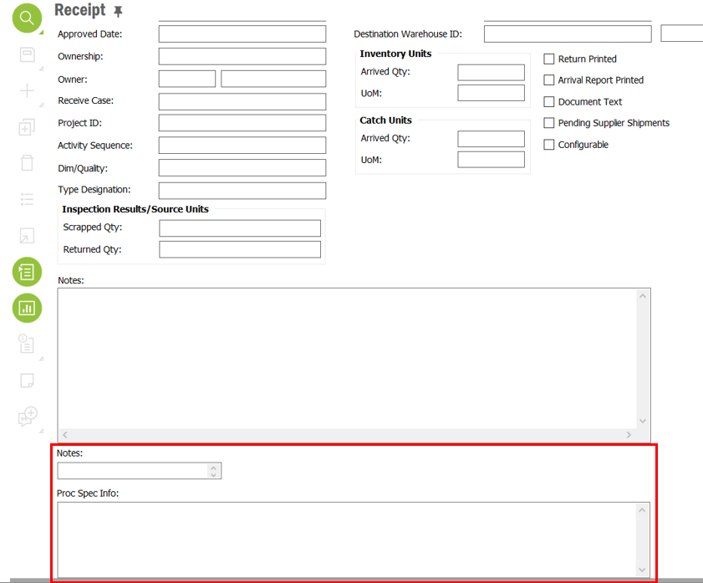

3. Proc Spec Info

Window: Warehouse Management/Part/Inventory Part

4. Notes

Window: Warehouse Management/Part/Inventory Part

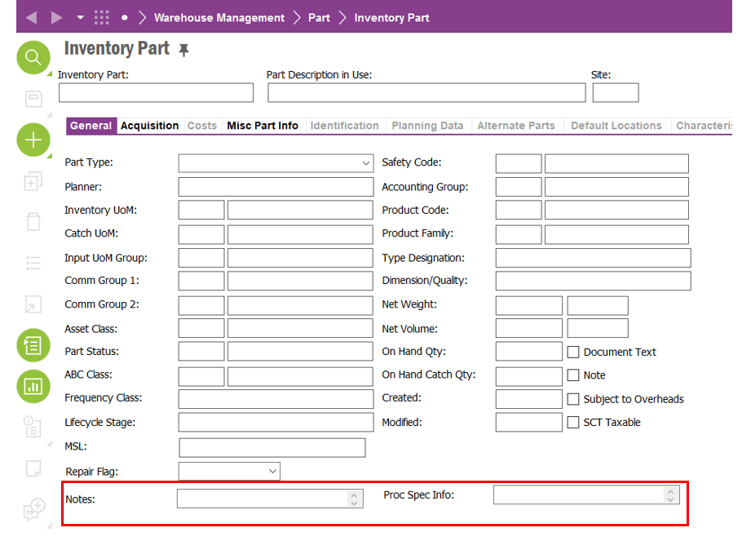

5. Proc Spec Info

Window: Part Master Data/Master Part/Part

